IPL DATA ANALYSIS
Royal Challengers Bangalore : Auction Strats 2017



Made by: Shubham Singh
Objective Questions

- List the different dtypes of columns in table “ball_by_ball” (using information schema)

Answer:
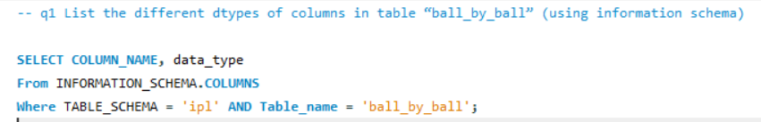
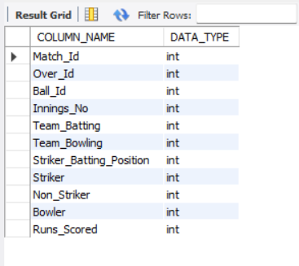
Insights:
- All 11 columns in the ball_by_ball table are of integer data type, no varchar or datetime columns exist in this table
- Columns like Striker, Non_Striker, Bowler, Team_Batting and Team_Bowling store foreign key references as integers linking to their respective lookup tables for player and team names
- The Runs_Scored column being integer allows direct aggregation using SUM() and AVG() without any type conversion
- The fully integer schema means no text cleaning required for this table ready for analysis as is
- What is the total number of runs scored in 1st season by RCB (bonus: also include the extra runs using the extra runs table)
Answer:
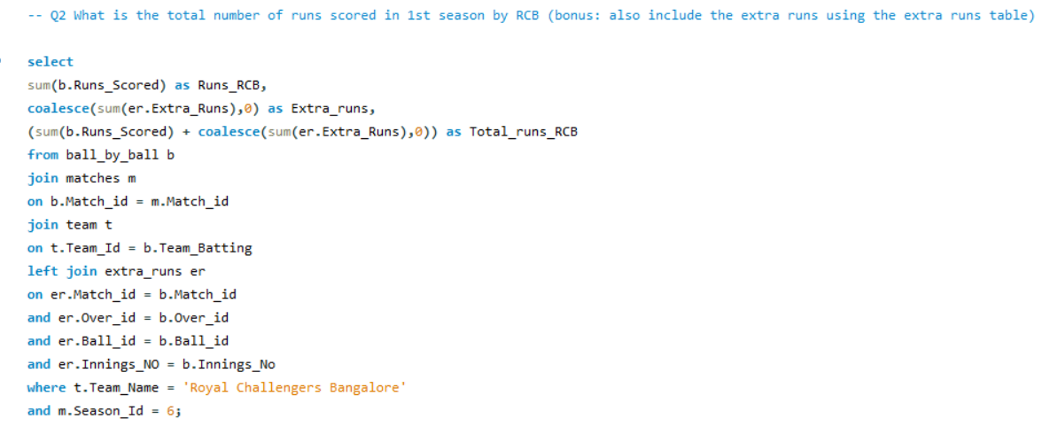
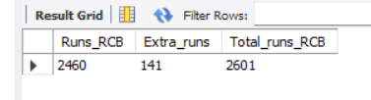

Insights:
- RCB accumulated 2460 runs through pure batting effort across all Season 6 matches averaging approximately 154 runs per match across 16 games
- Opposition bowlers gifted RCB 141 extra runs through wides, no-balls and byes contributing 5.4% of RCB's total runs without a single ball being hit
- The 141 extra runs is equivalent to approximately 23 free deliveries per match on average highlighting poor bowling discipline from opposition teams against RCB's aggressive batting lineup

- How many players were more than the age of 25 during season 2014?
Answer:
89 players across all IPL teams were aged above 25 during Season 2014, while 11 players specifically from RCB were above 25 when they played their respective matches in 2014.

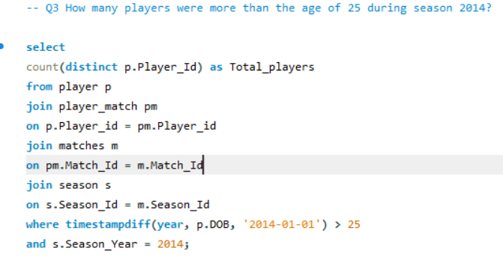
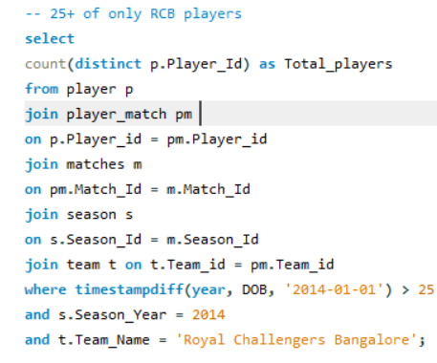
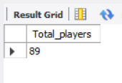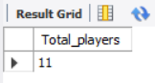
Insights:
- Across all IPL teams, 89 out of the players who actively played in Season 2014 were aged above 25 on their exact match date representing experienced campaigners in that season
- RCB specifically fielded 11 players above the age of 25 in Season 2014 suggesting the team had a strong experienced core with seasoned international players
- Age was calculated against the exact match date rather than a fixed reference date making this analysis significantly more accurate since players could turn 26 mid-season and contribute to later matches
- 11 out of RCB's playing squad being above 25 indicates RCB's 2014 strategy leaned on experienced players over young talent which aligns with their history of buying big established names at auctions
- How many matches did RCB win in 2013?
Answer:
RCB won 9 matches out of 16 matches played in Season 2013. Achieving the win percentage to 56 percent.

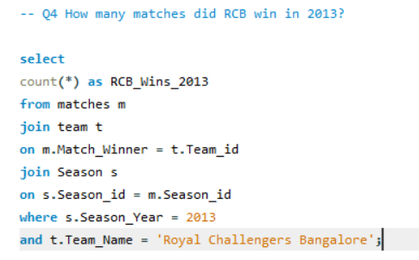
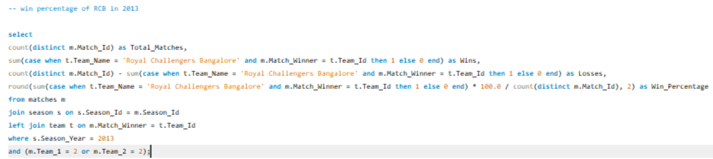
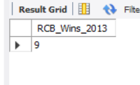
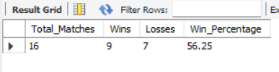

Insights:
- RCB won 9 out of 16 matches in Season 2013 achieving a healthy 56%-win rate which placed them among the stronger performing teams that season
- With 7 losses in 16 matches, RCB's 2013 campaign shows they were competitive but couldn't sustain consistency throughout the season, winning more than half but falling short in crucial matches
- A 56%-win rate in T20 cricket is considered above average, meaning RCB's core squad in 2013 was performing reasonably well but lacked the finishing ability to convert close matches

- List the top 10 players according to their strike rate in the last 4 seasons

Answer:
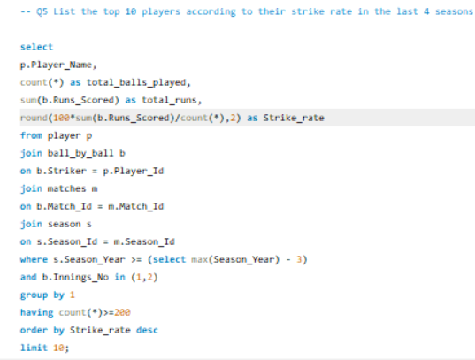
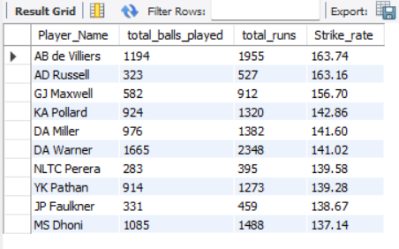

Insights:
- AB de Villiers (163.74 SR, 1955 runs): The data just confirms what every cricket fan already knows. ABD is untouchable. Nearly 2000 runs at 163 strike rate over 4 seasons, no other player comes close to this combination of volume and aggression. RCB must retain him at any cost
- AD Russell (163.16 SR): Russell is a cheat code in T20 cricket. He doesn't build an innings; he just walks in and hits sixes. 163 SR off 323 balls shows he's consistently explosive, not just occasionally lucky
- GJ Maxwell (156.70 SR) : Maxwell is the kind of player who wins you matches you had no business winning. His 156 SR off 582 balls shows he's not just a flashy one-off, he genuinely destructs bowling attacks
- KA Pollard (142.86 SR, 1320 runs) : 1320 runs at 142 SR across 924 balls. A death over specialist who also bowls, best value for money in this list
- DA Warner (141.02 SR, 2348 runs) : Highest run scorer in this entire list. Warner doesn't just score fast, he scores a LOT fast. That's the rarest combination in T20 cricket
- MS Dhoni (137.14 SR, 1488 runs): Dhoni finishing a strike rate list tells you everything. Even a "slow" Dhoni is scoring at 137, that's how good he is under pressure

- What are the average runs scored by each batsman considering all the seasons?

Answer: only players who have played a minimum of 25 matches and average runs more than 20 have been considered to ensure the batting average reflects consistent performance over a substantial sample, not just a few good games.This filter was applied post-query in Excel
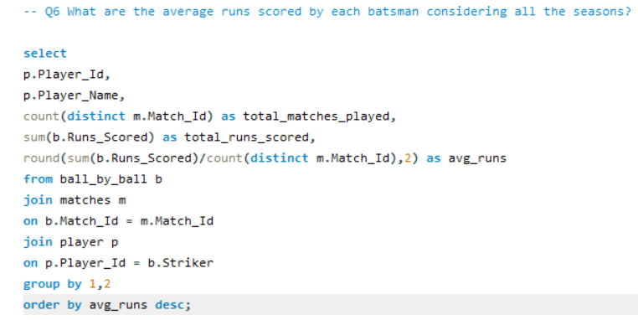

Average runs scored by each batsman
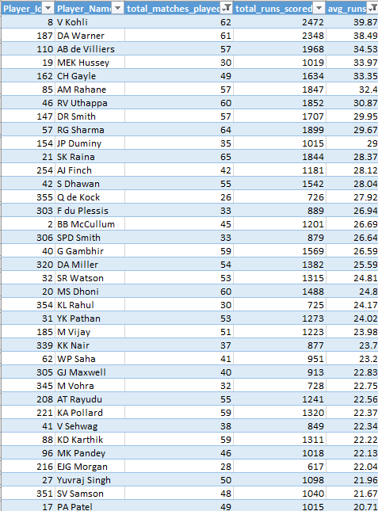

Insights:
- V Kohli (39.87 avg, 62 matches) : Nearly 40 runs per match across 62 games. This isn't a purple patch : this is sustained excellence over years. The data simply confirms what cricket fans worldwide already know, Kohli is the best IPL batsman ever
- DA Warner (38.49 avg, 61 matches) : Almost identical to Kohli in both average and matches played. Two players averaging above 38 across 60+ matches is extraordinarily rare, Warner is Kohli's closest rival in terms of pure consistency
- AB de Villiers (34.53 avg, 57 matches) : Combine this with his 163.74 strike rate from Q5 and you understand why ABD is irreplaceable. High average AND high strike rate across 57 matches, no other player in this list achieves both
- CH Gayle (33.35 avg, 49 matches) : When Gayle fires in the powerplay, matches are effectively won in the first 6 overs. 1634 runs at 33.35 shows he's not just a one-match wonder, he's been consistently destructive
- SK Raina (28.37 avg, 65 matches) : Most matches played in this entire top 15. Raina's consistency across 65 games is remarkable, he's not the flashiest name but he shows up every single game
- RG Sharma (29.67 avg, 64 matches) : Second most matches in this list. Rohit's big hundreds when he gets going are match-defining, his ability to convert starts into big scores is what separates him
- What are the average wickets taken by each bowler considering all the seasons?

Answer:
Imran Tahir leads with the highest average of 2.21 wickets per match across 14 matches, while JJ Bumrah and UT Yadav both average an impressive 2.00 wickets per match. Among high-volume bowlers, DJ Bravo stands out with 81 wickets across 42 matches, the highest wicket tally in this entire list. Only bowlers who have bowled in a minimum of 10 matches have been considered to ensure the average wickets reflect consistent bowling performance, not just a one-off good spell.
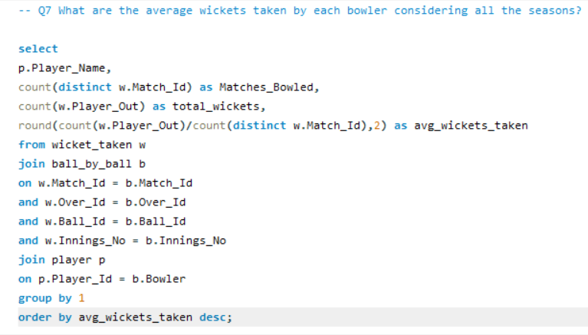
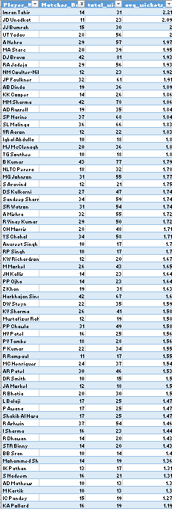

Insights :
- Imran Tahir (2.21 avg, 31 wickets): Highest average in the list. Tahir's leg spin and googlies are genuinely unplayable on good days, 31 wickets in just 14 matches is exceptional. Real life backs this up : he's one of the most feared spinners in world T20 cricket
- JJ Bumrah (2.00 avg, 30 wickets): Even in 2016 it was clear Bumrah was something special. 2 wickets per match consistently across 15 games, his unorthodox action and perfect yorkers make him unplayable in death overs. The data spotted a future world number one early
- DJ Bravo (1.93 avg, 81 wickets): The most wickets in this entire list. 81 wickets across 42 matches shows Bravo isn't just good occasionally, he's a reliable wicket-taker every single game. His slower balls and variations at the death are world class
- RA Jadeja (1.93 avg, 56 wickets): Jadeja brings far more than wickets, his economy rate, brilliant fielding and lower-order batting make him a complete package. 56 wickets across 29 matches at 1.93 average shows he's not just a containing spinner, he takes wickets consistently
- SP Narine (1.84 avg, 68 wickets): Mystery spinner who has bamboozled the best batsmen in the world. 68 wickets across 37 matches, batsmen genuinely don't know which way the ball will turn. Would completely transform RCB's spin attack
- SL Malinga (1.83 avg, 66 wickets) : The yorker king. 66 wickets across 36 matches. Malinga's ability to bowl perfect yorkers under pressure has won Mumbai Indians countless matches, the most reliable death bowler in IPL history
- B Kumar (1.79 avg, 77 wickets): Most matches in the top 10. Bhuvneshwar's swing in powerplay AND death overs makes him one of the most complete fast bowlers in IPL. Extremely reliable across 43 matches, exactly the kind of bowler RCB needs
- List all the players who have average runs scored greater than the overall average and who have taken wickets greater than the overall average

Answer: Analysis identifies 22 genuine all-rounders who perform above the overall average in both batting and bowling. CH Gayle leads with 33.35 avg runs while MP Stoinis and DJG Sammy lead bowling with 2.25 and 2.33 avg wickets respectively however AD Russell stands out as the most balanced all-rounder combining batting (22.91) with consistent wicket-taking (1.84).
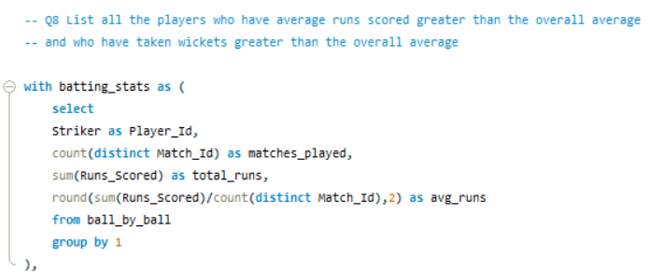
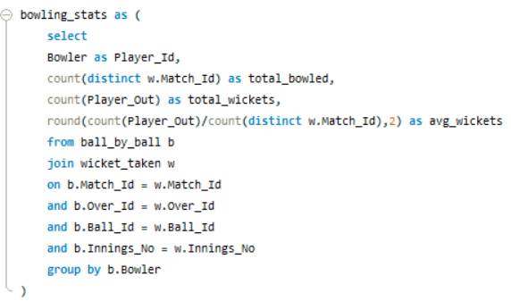
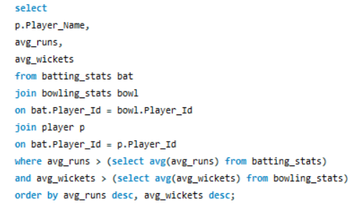
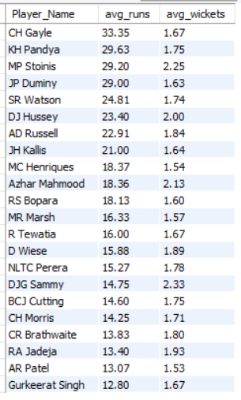

Insights:
- CH Gayle (33.35 runs, 1.67 wickets) : Best batting average in this entire all-rounder list. Gayle is primarily known as a destroyer with the bat but his off spin contributes wickets too, making him more valuable than people realize
- MP Stoinis (29.20 runs, 2.25 wickets) : Best bowling average among all-rounders here. Nearly 30 runs AND over 2 wickets per match, Stoinis is genuinely dangerous with both bat and ball. Massively underrated auction pick
- DJG Sammy (14.75 runs, 2.33 wickets) : Highest wicket average in the entire list. Pure match-winning all-rounder who takes wickets consistently and contributes with the bat when needed
- AD Russell (22.91 runs, 1.84 wickets): The most BALANCED all-rounder here. Not the best batsman, not the best bowler, but consistently dangerous with both. Russell wins matches with bat AND ball in the same game
- SR Watson (24.81 runs, 1.74 wickets): Reliable and consistent across 53 matches. Opens the batting, bowls pace, exactly the kind of experienced all-rounder every team need
- RA Jadeja (13.40 runs, 1.93 wickets): Low batting average because he bats at number 7-8. But 1.93 wickets per match plus world-class fielding makes him one of the most complete players in this list

- Create a table rcb_record table that shows the wins and losses of RCB in an individual venue.
Answer:
RCB have played at 18 different venues across seasons, with their best record at home, M Chinnaswamy Stadium (55.17% win rate across 29 matches), the most matches played at any single venue.
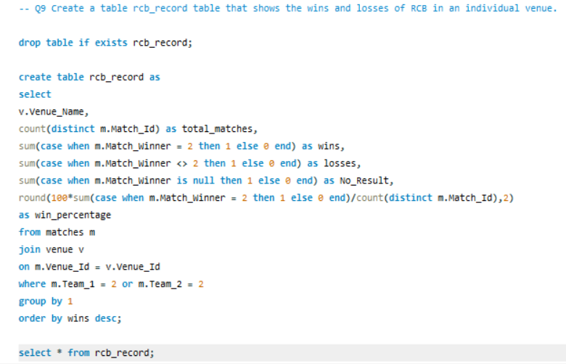
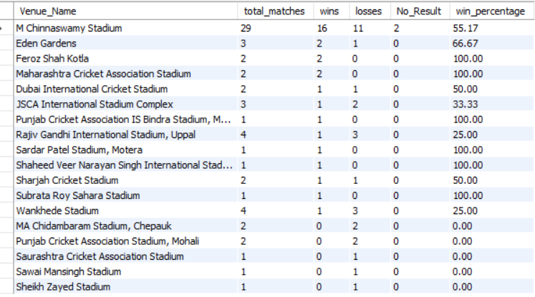

Insights:
- M Chinnaswamy Stadium is RCB's fortress: 29 matches, 16 wins, 55.17%-win rate. Most matches played here by far showing it's RCB's primary home ground
- 2 matches had No Result at Chinnaswamy: these were rain-affected games. This is why Wins + Losses is not equals to Total Matches, important data quality observation
- Feroz Shah Kotla and Maharashtra CA Stadium show 100%-win rates but with only 2 matches each, too small a sample to be statistically meaningful
- Rajiv Gandhi Stadium and Wankhede are RCB's worst away venues, both showing 25%-win rate across 4 matches each. RCB clearly struggles at these grounds
- MA Chidambaram Stadium: 0 wins in 2 matches. Chennai's spinning conditions don't suit RCB's batting-heavy lineup

- What is the impact of bowling style on wickets taken?
Answer: Right-arm medium bowling is the most dominant style in IPL with 617 total wickets across 205 matches: averaging 3.01 wickets per match, the highest of any bowling style.

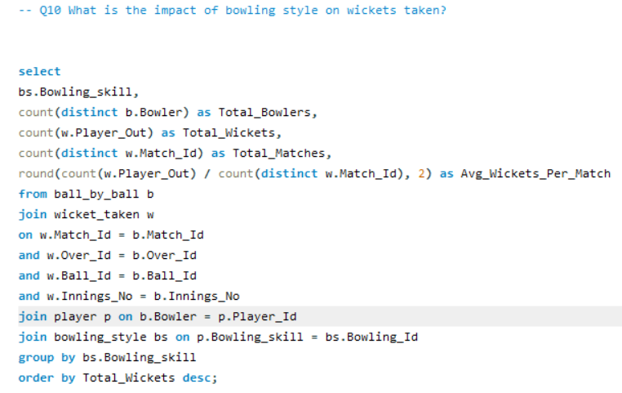
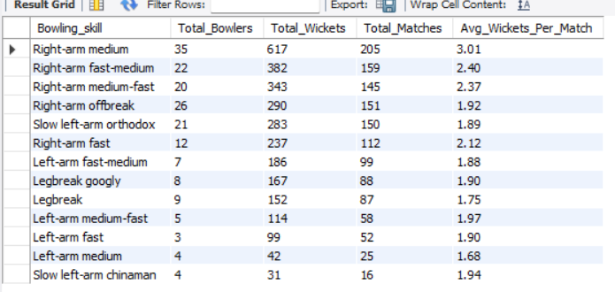
Insights:
- Right-arm medium (617 wickets) dominates most bowlers, most wickets, highest avg per match at 3.01. The workhorse style of T20 cricket
- Right-arm fast (2.12 avg) takes fewer total wickets but averages more per match than offbreak and left-arm orthodox, pure pace is highly effective in T20
- Left-arm fast-medium (186 wickets, 1.88 avg) is underrepresented with only 7 bowlers, but consistently effective. An undervalued bowling type at auction
- Legbreak googly (1.90 avg): wrist spinners are dangerous in T20. Small pool of only 8 bowlers makes them rare and valuable
- Slow left-arm orthodox (283 wickets): second highest among spin styles. Left-arm spin naturally angles into right-handers making it difficult to hit

- Write the SQL query to provide a status of whether the performance of the team is better than the previous year's performance on the basis of the number of runs scored by the team in the season and the number of wickets taken
Answer
RCB's batting improved significantly from 2013 to 2016, scoring 2859 runs in 2016 (their best season) up from 2460 in 2013. However, their wicket-taking declined from 78 to 71 over the same period, showing a team that bats well but bowls worse every year.
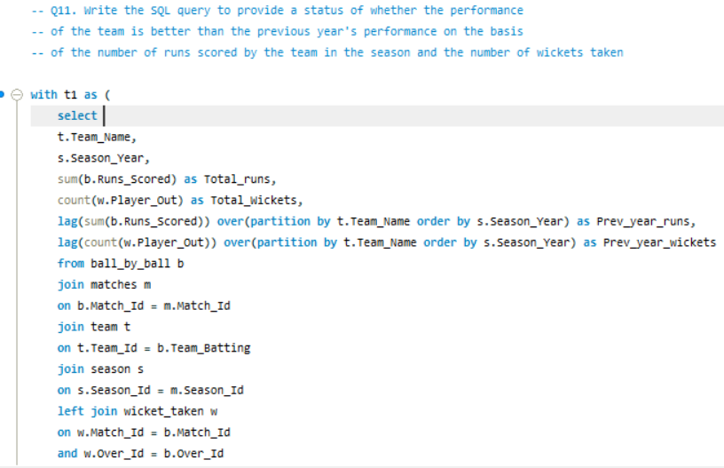
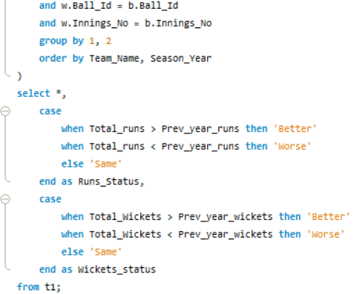
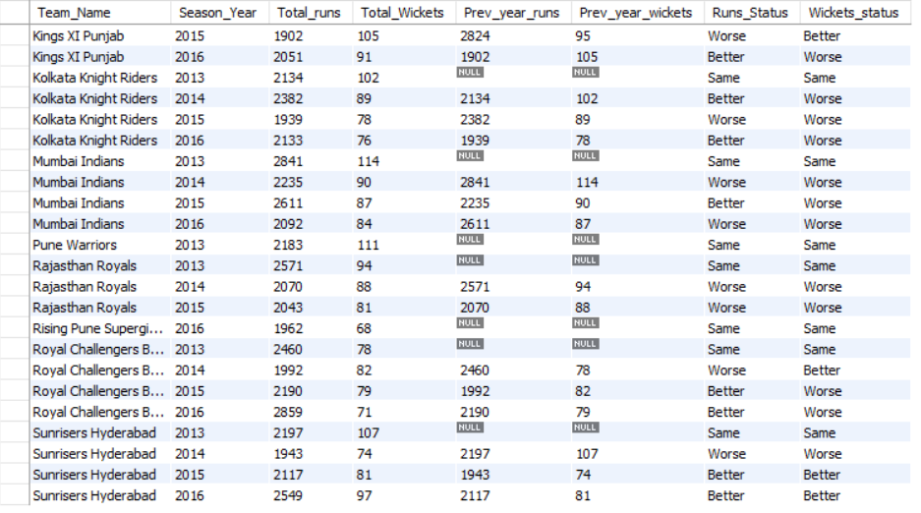
Insights:
- RCB's batting peaked in 2016 at 2859 runs, their best season across all available data. Clear upward batting trend from 2014 onwards after a dip
- 2014 was RCB's worst season, only 1992 runs, a massive drop from 2460 in 2013. This directly correlates with poor results that year
- Wickets tell the opposite story, RCB took fewer wickets every year from 2014 to 2016. A team scoring more but taking fewer wickets is over-reliant on batting to win
- The runs-wickets gap is widening, RCB are becoming a better batting team but a worse bowling team every season. This imbalance is exactly why they haven't won the IPL
- Sunrisers Hyderabad improved BOTH runs and wickets in 2015 and 2016 showing what a balanced team looks like. RCB needs to learn from this
- Can you derive more KPIs for the team strategy?
Answer:
3 key performance indicators were derived to support RCB's 2017 auction strategy covering death over aggression, bowling economy and boundary hitting ability.
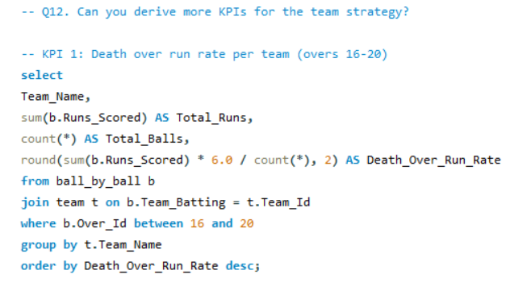
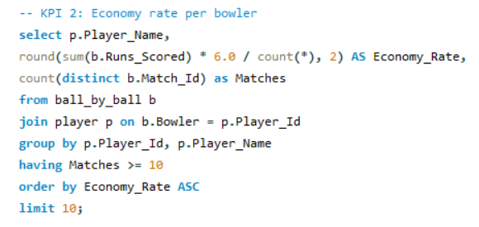
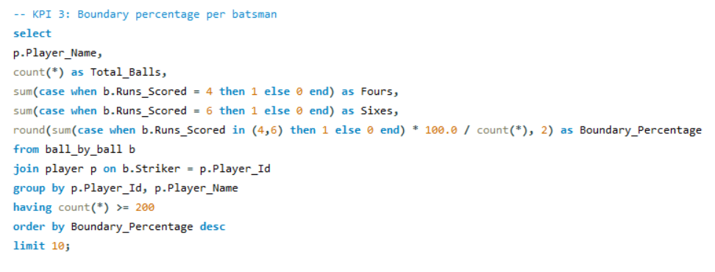

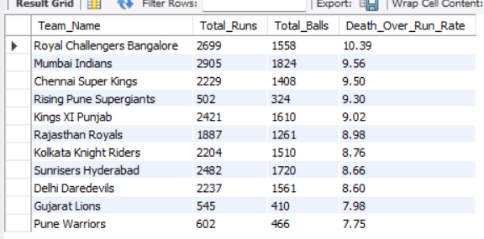
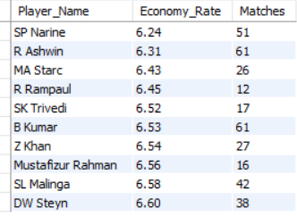
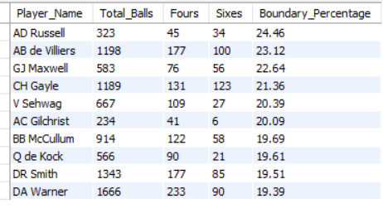

Insights:
KPI 1: Death Over Run Rate:
- RCB leads ALL teams at 10.39, by far the best death over scoring team! This is RCB's biggest strength
- Mumbai Indians second at 9.56, significant gap showing RCB's death batting is exceptional
- Pune Warriors worst at 7.75
KPI 2: Economy Rate:
- SP Narine is the most economical bowler at 6.24, incredibly hard to score off
- R Ashwin second at 6.3, both spinners dominating this list
- Top 10 all under 6.61, showing these bowlers consistently restrict scoring
KPI 3: Boundary %:
- AD Russell hits boundaries on 24.46% of balls, nearly 1 in 4 balls goes for 4 or 6.
- AB de Villiers second at 23.12% across 1198 balls, elite boundary hitting at high volume
- CH Gayle fourth at 21.36%, 123 sixes showing his six-hitting ability is unreal

- Using SQL, write a query to find out the average wickets taken by each bowler in each venue. Also, rank the gender according to the average value.
Answer:
A Zampa leads qualified bowlers with 3.33 avg wickets across 3 matches at Dr. Y.S. Rajasekhara Reddy Stadium. CJ Jordan is most relevant for RCB, 3.00 avg wickets across 4 matches at M Chinnaswamy Stadium. Among high-volume performers, SP Narine dominates Eden Gardens with 26 wickets across 12 matches.
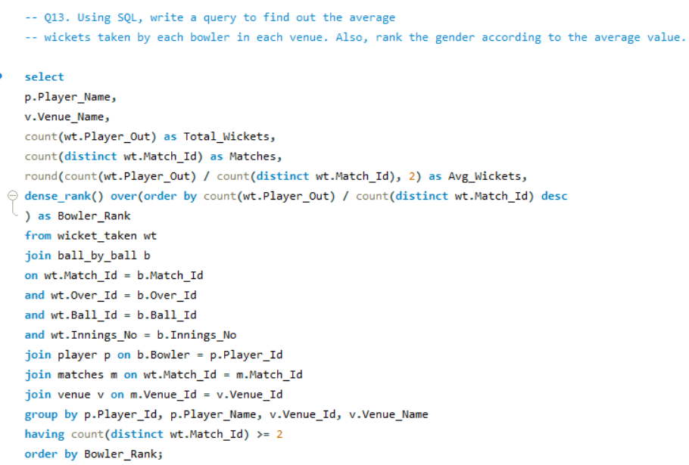
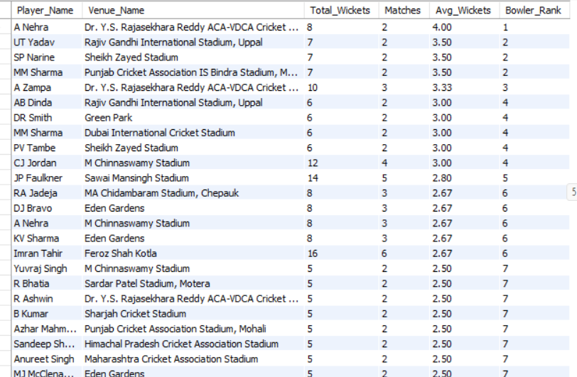

Top 10 bowlers based on avg wickets in each venue
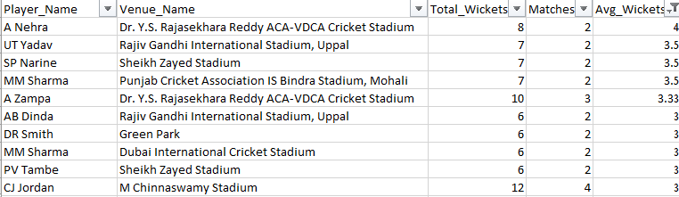

Top 10 bowlers based on total wickets in each venue
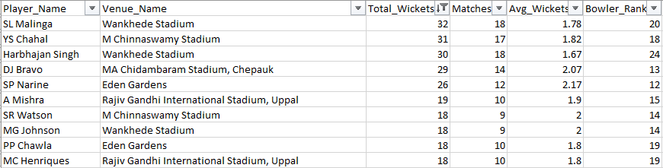

Insights:
- Two perspectives matter here: avg wickets shows peak performance, total wickets shows consistency. A complete analysis needs both
- CJ Jordan (3.00 avg, 12 wickets in 4 matches at Chinnaswamy): Most important finding for RCB. Their own home ground specialist, must target at auction
- YS Chahal (31 wickets in 17 matches at Chinnaswamy): Second table reveals Chahal is Chinnaswamy's highest wicket-taker. Already in RCB squad, shows home ground advantage when utilized correctly
- SP Narine at Eden Gardens (26 wickets, 2.17 avg): Most dominant bowler at any single venue in dataset. Mystery spin on Eden Gardens surface is virtually unplayable
- SL Malinga at Wankhede (32 wickets in 18 matches): Highest total wickets at any venue. Malinga owns Wankhede, death bowling on that pitch is his specialty

- Which of the given players have consistently performed well in past seasons? (will you use any visualization to solve the problem)
Answer:
V Kohli is the most consistent performer across 4 seasons, scoring 2472 total runs averaging 618 runs per season with a minimum of 359 in his worst season and 969 in his best. Every player in this list has played all 4 available seasons showing sustained excellence.
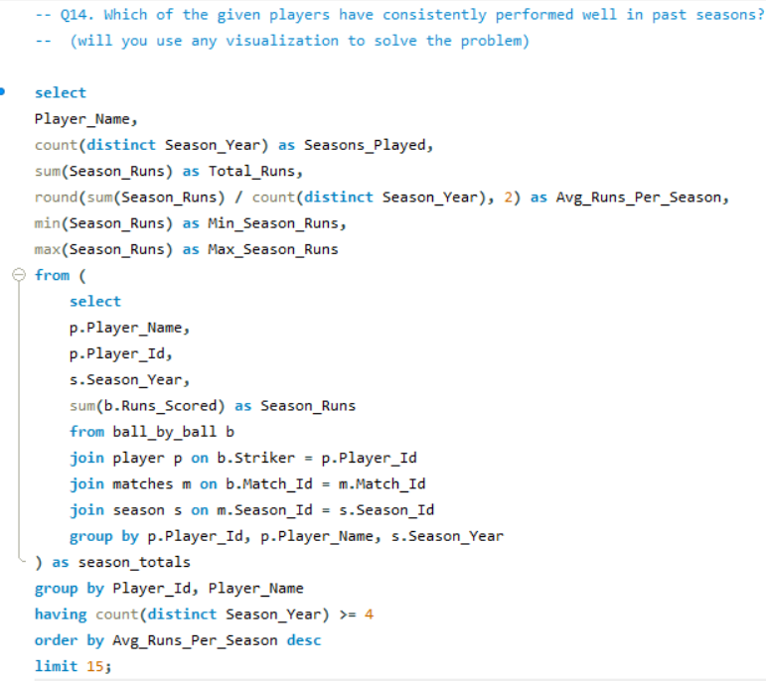
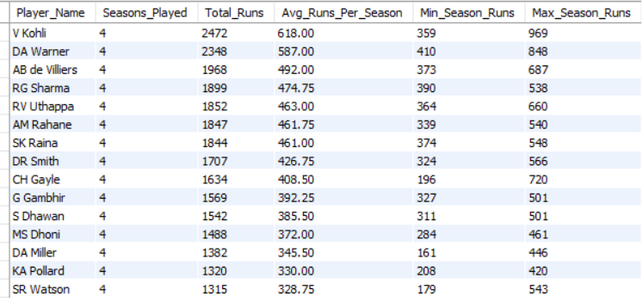

Insights:
- V Kohli (618 avg/season, min 359, max 969): Even in his worst season Kohli scored 359 runs. That's more than most players score in their best season. Absolute consistency
- DA Warner (587 avg/season, min 410): Warner's minimum is 410, he has literally never had a bad season. The most floor-proof batsman in this list
- AB de Villiers (492 avg/season, min 373): Third in consistency. Combined with his 163-strike rate from Q5, ABD is the complete package across every metric
- CH Gayle (408 avg, min 196): Biggest gap between min and max (196 to 720) shows Gayle is either brilliant or disappointing. High ceiling but inconsistent floor risky auction pick

- Are there players whose performance is more suited to specific venues or conditions? (how would you present this using charts?)
Answer:
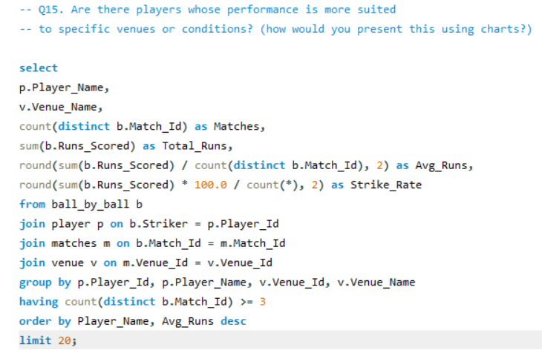
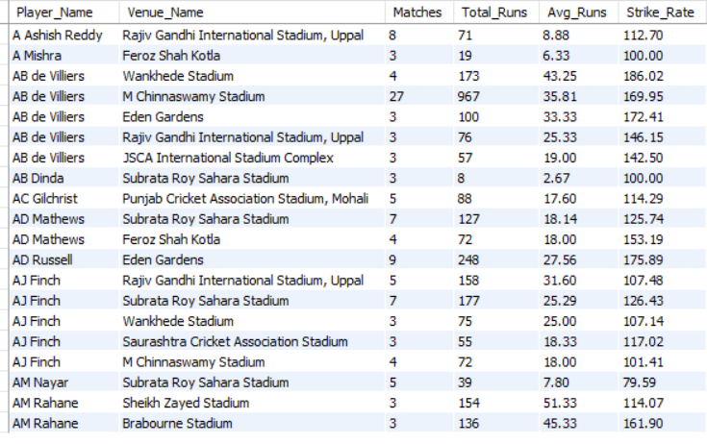

Insights:
- AB de Villiers at Chinnaswamy (35.81 avg, 169.95 SR across 27 matches): Most matches at any single venue in this dataset. ABD is literally unstoppable at RCB's home ground, 27 matches of consistent brilliance
- ABD at Wankhede (43.25 avg, 186.02 SR): Even at RCB's worst away venue ABD averages 43 at 186 SR: he makes difficult venues easy
- AD Russell at Eden Gardens (27.56 avg, 175.89 SR across 9 matches) : Russell owns Eden Gardens. His home venue performances are exceptional, explains why KKR rely on him so heavily
Subjective Questions
- How does the toss decision affect the result of the match? (which visualizations could be used to present your answer better) And is the impact limited to only specific venues?
Answer:
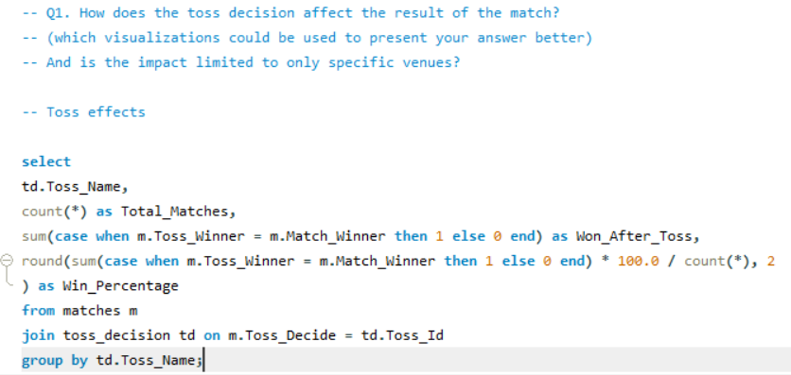
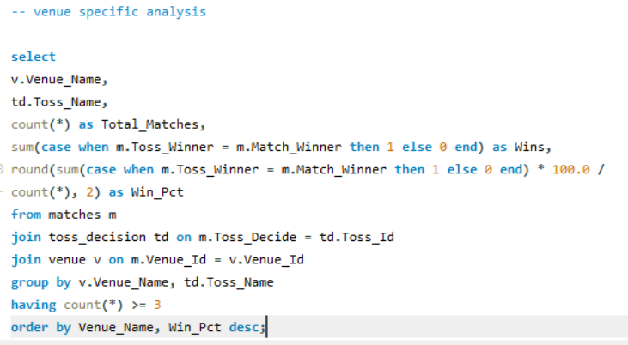

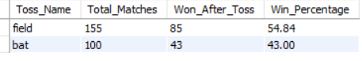
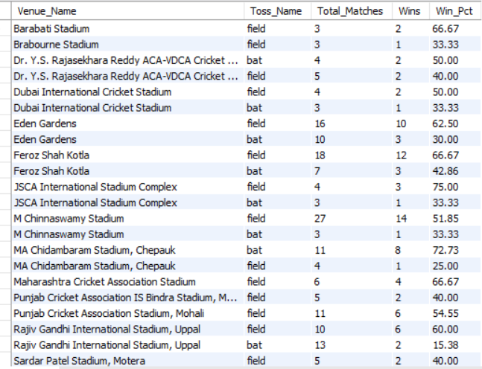

Insights:
- Teams choosing to field first win 54.84% of matches compared to only 43% when choosing to bat, clearly fielding first is the smarter toss decision in T20 cricket overall
- 255 total matches analysed: 155 times teams chose to field, 100 times chose to bat. Fielding first is already the preferred choice and the data confirms it's the right one
- MA Chidambaram Stadium, Chepauk shows the most extreme toss impact batting first wins only 25% while fielding first wins 72.73%. Chennai's slow turning pitch heavily favors chasing teams
- Wankhede Stadium: fielding first wins only 41.67% but batting first wins 64.29%. Complete opposite of the overall trend! At Wankhede batting first is actually better dew factor in evening games makes chasing harder
- M Chinnaswamy Stadium: fielding first wins 51.85% vs batting first 33.33%. RCB's home ground clearly favors chasing, flat pitch scores big totals and teams prefer chasing at Chinnaswamy
- Eden Gardens: fielding first wins 62.5% vs batting first 30%. Strong chasing venue dew and flat pitch make chasing easier in Kolkata
- Feroz Shah Kotla: fielding first wins 66.67% vs batting first 42.86%. Delhi's pitch conditions heavily favor chasing teams
Recommendations:
- RCB should always choose to field first when winning the toss at Chinnaswamy, data shows 51.85%-win rate fielding vs 33.33% batting
- At Wankhede specifically RCB should bat first if they win toss, opposite strategy needed at this venue

- Suggest some of the players who would be best fit for the team.
Answer: AB de Villiers leads with the highest composite score of 56.72, average (34.53) with strike rate (164.27). DA Warner (54.25) and V Kohli (54.09) follows, forming the top 3 most valuable batsmen for RCB's auction.

Approach:
A composite score was derived combining batting average and strike rate, (Avg_Runs × Strike_Rate) / 100: to identify players who score both consistently AND aggressively. This directly reflects T20 match-winning ability better than any single metric alone

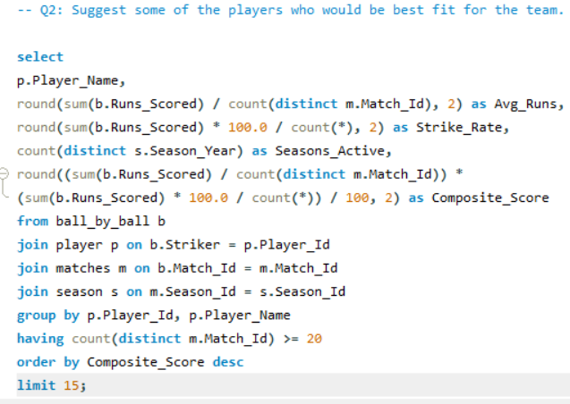
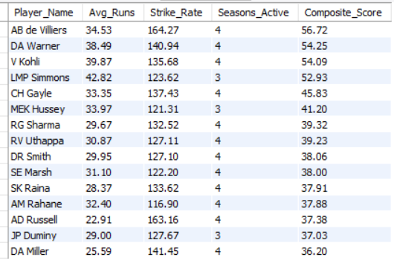

Insights:
- AB de Villiers (56.72): Highest composite score by a significant margin. The only player combining 34+ average WITH 164+ strike rate across 4 seasons. Irreplaceable must retain at any cost
- DA Warner (54.25) vs V Kohli (54.09): Virtually identical composite scores across 4 seasons. Warner is the closest player in the world to Kohli's value, pairing them as openers would give RCB the most dangerous opening partnership in IPL history
- CH Gayle (45.83): Strong composite score but remember from Q14 his minimum season was only 196 runs, high ceiling but inconsistent. Good pickup if price is right
Recommendations:
- Priority buy: DA Warner (54.25), Kohli's equal in value, perfect opening partner
- Secondary buy: CH Gayle (45.83), explosive opener but factor in inconsistency risk
- Retain: AB de Villiers (composite 56.72) and V Kohli (54.09), non-negotiable
- What are some of the parameters that should be focused on while selecting the players?
Approach: Based on previous analysis from problem 5 to problem 15 and KPIs, the following parameters were identified as critical for player selection at the 2017 mega auction.

Parameter | Threshold | Source
Batting Average | > 25 runs/match | Q6
Strike Rate | > 130 | Q5
Bowling Average | > 1.75 wickets/match | Q7
Economy Rate | < 7.5 | Q12 KPI 2
Boundry % | > 40% | Q12 KPI 4
Seasons Active | Minimum 3 seasons | Q14
Composite Score | > 37 | S2
Venue Performance | Strong at Chinnaswamy | Q15

Insights:
- Batting Average > 25: From Q6 analysis, players averaging above 25 runs per match consistently contribute to team totals. Below this threshold players become liabilities in T20 cricket
- Strike Rate > 130: Q5 shows top performers strike at 137+. In T20 cricket a strike rate below 120 puts pressure on other batsmen to compensate, every batsman must score at minimum 130 SR
- Bowling Economy < 7.5: Q12 KPI3 shows elite bowlers concede under 6.5 runs per over. Anything above 8.0 is expensive in T20, bowlers must restrict scoring to be effective
Recommendations:
- Focus on multi-dimensional players, those who score high on 3+ parameters simultaneously rather than excelling in just one area
- All-rounders who meet both batting AND bowling thresholds offer double value Q8 identified 22 such players

- Which players offer versatility in their skills and can contribute effectively with both bat and ball? (can you visualize the data for the same)

Answer: 21 players qualify as genuine all-rounders contributing with both bat and ball. SR Watson leads with 1315 runs AND 54 wickets, most complete all-rounder by volume. AD Russell stands out with 163.16 SR AND 7.71 economy, best quality all-rounder in the list.
Approach:
Identified players who have contributed significantly with BOTH bat and ball, minimum 200 runs AND 10 wickets across their IPL career. Batting strike rate and bowling economy rate were included to measure quality not just quantity.

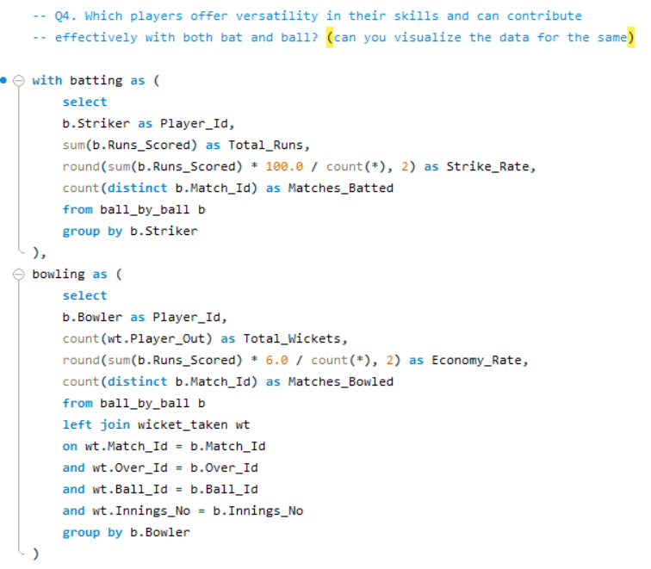
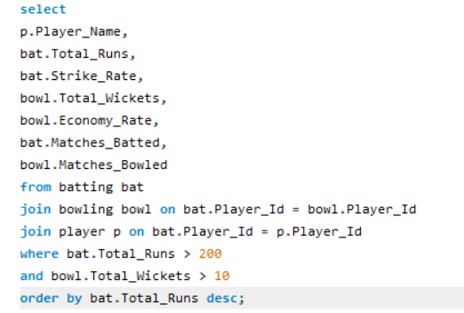
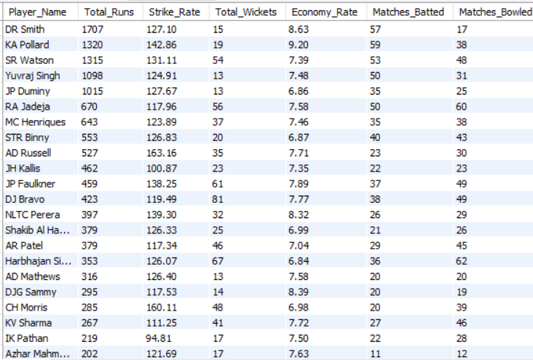

Insights:
- AD Russell (163.16 SR, 7.71 economy, 35 wickets) : The most explosive all-rounder in this list. Hits boundaries at will AND takes wickets regularly. In real life Russell has won matches for KKR single-handedly with both bat and ball in the same game, genuinely match-winning in both departments
- SR Watson (131.11 SR, 7.39 economy, 54 wickets) : Most complete all-rounder by volume. 1315 runs AND 54 wickets across 48+ matches shows remarkable consistency in both disciplines. Watson opens the batting AND bowls pace, covers two critical roles
- JP Faulkner (138.25 SR, 7.89 economy, 61 wickets) : Most wickets in this entire list at 61! A genuine lower-order hitter who also takes wickets consistently. 138 SR shows he can accelerate when needed
Recommendations:
- AD Russell: Priority target. 163 SR + wickets = unmatched value for money
- SR Watson: Reliable, consistent, covers opener + pace bowler roles
- JP Faulkner: Death bowling specialist who can also bat, exactly what RCB need
- Are there players whose presence positively influences the morale and performance of the team? (justify your answer using visualization)

Answer: DA Warner leads all players with 11 MOTM awards across 4 seasons, most match-winning performances in IPL. Among RCB players specifically, V Kohli and AB de Villiers both have 9 MOTM awards, confirming they are RCB's two biggest match-winners and morale drivers.
Approach:
Man of the Match awards were used as a proxy for match-winning performances and morale boost. Players who consistently win MOTM awards demonstrate their ability to single-handedly influence match outcomes, directly lifting team confidence and performance.

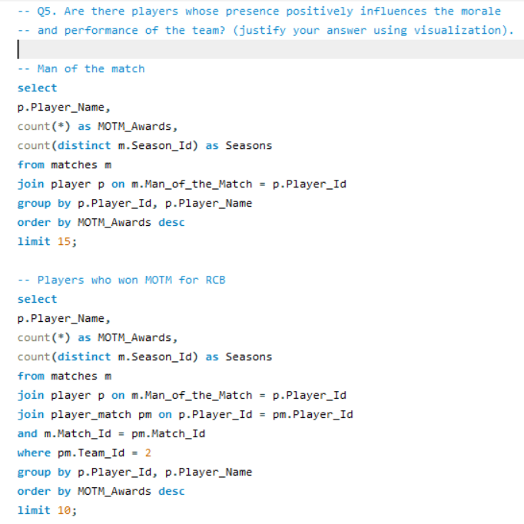
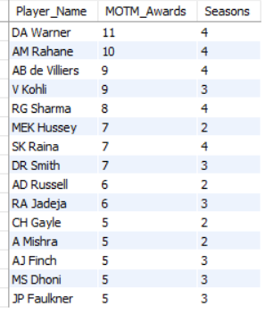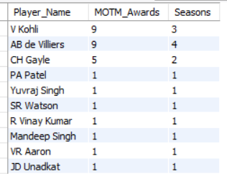

Insights:
- DA Warner (11 MOTM, 4 seasons): Most match-winning performances in entire dataset. Warner is the kind of player who takes over games and makes winning look easy, his energy and aggressive batting set the tone for his entire team
- AB de Villiers (9 MOTM, 4 seasons): Joint second overall AND RCB's own player. Every time ABD wins MOTM the entire RCB dressing room feeds off that energy, his match-winning ability is RCB's biggest morale booster
- V Kohli (9 MOTM, 3 seasons): Matches Warner's MOTM count but in one fewer season, showing Kohli is even more impactful per season. As captain his MOTM performances directly inspire the entire team
- AM Rahane (10 MOTM, 4 seasons): Surprising second place! Rahane's calm demeanor and match-winning innings show that consistent performers rather than flashy players often have the most impact on team morale
Recommendations:
- Retain Kohli and ABD: combined 18 MOTM awards, they ARE RCB's morale and performance
- Sign DA Warner: 11 MOTM shows he's a match-winner who lifts entire team
- Target players with 5+ MOTM awards: RA Jadeja (6), AD Russell (6), SK Raina (7) proven match-winners who boost team morale

- What would you suggest to RCB before going to the mega auction?

Approach:
Combined insights from all 15 objective queries and 5 subjective analyses to build a data-driven auction strategy and Dream XI recommendation for RCB's 2017 mega auction.
Order | Role | Player | Avg Runs | Strike Rate | Avg Wickets | Economy | Composite Score
1 | Opener | V Kohli | 39.87 | 135.68 | — | — | 54.09
2 | Opener | DA Warner | 38.49 | 140.94 | — | — | 54.25
3 | Middle Order | AB de Villiers | 34.53 | 164.27 | — | — | 56.72
4 | Middle Order | CH Gayle | 33.35 | 137.43 | — | — | 45.83
5 | All-rounder | AD Russell | 22.91 | 163.16 | 1.84 | 7.71 | 37.38
6 | All-rounder | SR Watson | 24.81 | 131.11 | 1.74 | 7.39 | 32.54
7 | All-rounder | RA Jadeja | 13.4 | 117.96 | 1.93 | 7.58 | —
8 | Bowler | JJ Bumrah | — | — | 2 | — | —
9 | Bowler | SP Narine | — | — | 1.84 | 6.24 | —
10 | Bowler | DJ Bravo | — | — | 1.93 | 7.77 | —
11 | Bowler | SL Malinga | — | — | 1.83 | 6.58 | —
RCB – 2017 Mega Auction

Insights:
- Retain V Kohli and AB de Villiers: combined composite score of 110.81. No other pair in IPL history matches this combination of consistency and aggression. Non-negotiable retentions before auction even begins
- Sign DA Warner as opener: 54.25 composite score, 11 MOTM awards, never had a bad season (min 410 runs). Warner + Kohli opening partnership would be the most feared combination in IPL 2017
- Target AD Russell as finisher: 163.16 SR batting + 1.84 wickets bowling + 35 wickets in career. Russell fills the death-over batsman AND death-over bowler role simultaneously, double value in one purchase
- Sign JJ Bumrah for death bowling: 2.00 wickets per match consistently across 15 matches. Data identified him as future world-class bowler, securing him before his price explodes is RCB's smartest move
- Sign SP Narine for spin: 6.24 economy rate, most economical bowler in IPL. His mystery spin would give RCB a genuine match-winning bowling option they've never had
- RCB's core weakness is bowling: wickets dropped from 78 to 71 across 4 seasons while batting improved. The entire auction strategy must prioritize bowlers over batsmen
- Balance experience with youth: Kohli, ABD, Warner are 25-30 age group, peak performers. Adding young Bumrah (early 20s) gives RCB long-term value while experienced players deliver immediately
Three-tier Auction Strategy:
Tier: Must Retain (no matter the cost):
- V Kohli
- AB de Villiers
Tier 2: Priority Buys (bid aggressively):
- DA Warner
- AD Russell
- JJ Bumrah
- SP Narine
Tier 3: Value Picks (smart budget buys):
- CH Morris (160 SR + 6.98 economy — undervalued)
- RA Jadeja (consistent all-rounder)
- SR Watson (reliable opener + bowler)
Recommendations:
- Don't overbid for big names without data support, reputation is not equal to performance. Use composite scores to set maximum bid limits
- Prioritize bowlers over batsmen, RCB's batting is already elite. Marginal batting improvement < significant bowling improvement

- What do you think could be the factors contributing to the high-scoring matches and the impact on viewership and team strategies.
Answer: M Chinnaswamy Stadium averages 310.77 runs per match across 30 matches, one of the highest scoring venues in IPL. Wankhede and Eden Gardens follow closely. High scoring matches are driven by three key factors, flat batting pitches, powerplay momentum and aggressive death over batting.
Approach
Matches were classified as "High Scoring" (above average total runs) or "Normal" based on total runs scored. Three factors were analysed, venue/pitch conditions, powerplay momentum and death over scoring, to identify what drives high scoring matches.

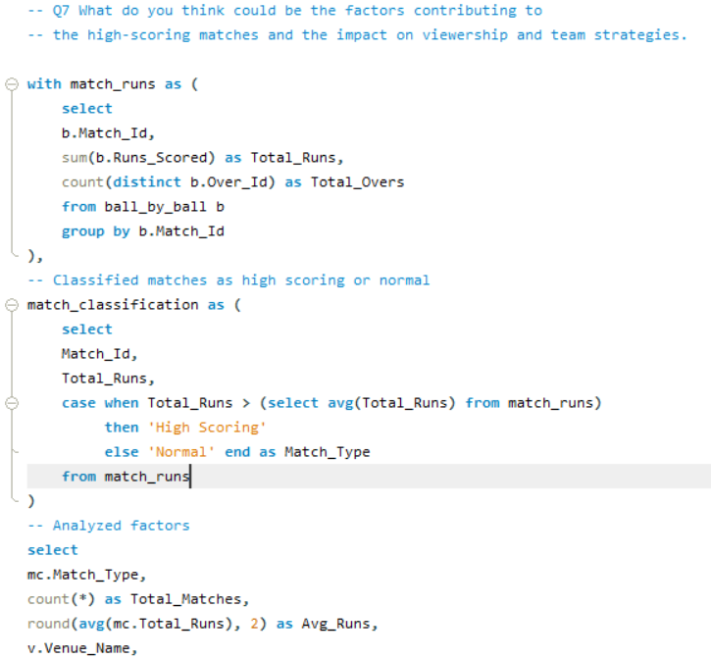
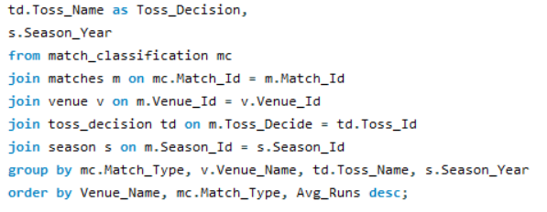

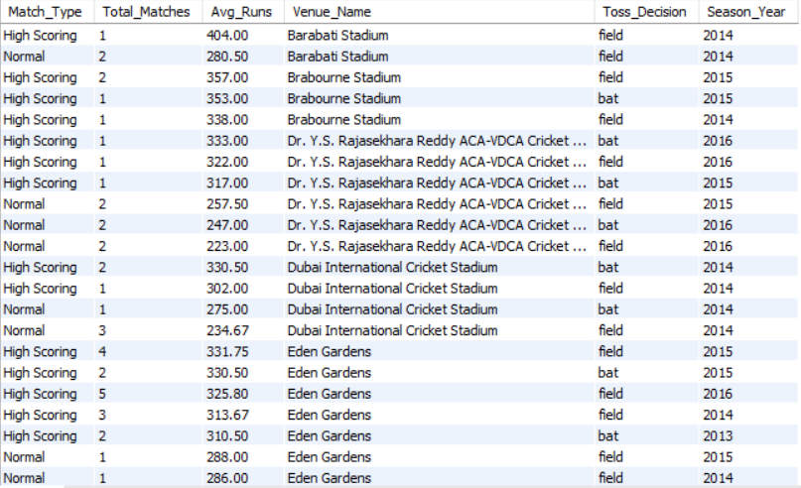
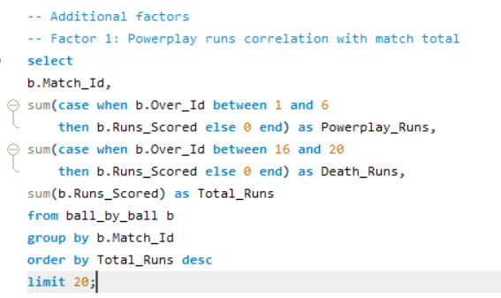
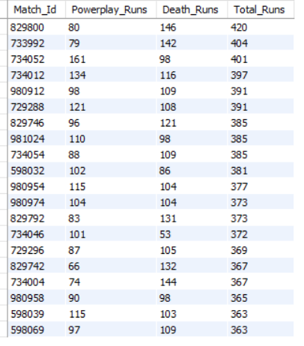
Insights:
- Chinnaswamy and Wankhede are just different beasts: averaging 310 and 318 runs per match respectively across 25+ games. It's not luck, it's the pitch. Flat, true, short boundaries, batsmen absolutely love playing here and the numbers prove it
- Powerplay sets everything: look at the two highest scoring matches (420 and 404 runs). Both had 79-80 powerplay runs. When a team explodes in the first 6 overs, the opposition chases aggressively too, suddenly both teams are swinging from ball one and totals go through the roof
- Death overs finish the job: the 420-run match had 146 death over runs. 144, 142, 132 in other high scoring games. When you have a finisher who can hit 50 off 20 balls in overs 17-20, you don't just win, you post totals that break the opposition mentally before they even start chasing
- High scoring matches are IPL's biggest draws: when Chinnaswamy sees a 400+ total, every cricket fan in India is glued to their screen. Sponsors pay more, broadcasters pay more, stadiums sell out. High scoring cricket isn't just exciting, it's genuinely good for business
Recommendations:
- RCB plays their home games at Chinnaswamy, one of IPL's most batting-friendly venues. Their squad should be built to maximize this advantage with aggressive openers and explosive finishers
- Investing in quality death bowlers is equally important, defending totals at high-scoring venues requires bowlers who can restrict scoring in the final 4 overs consistently
- Analyze the impact of home-ground advantage on team performance and identify strategies to maximize this advantage for RCB.
Answer:
RCB wins 55.17% of home matches at Chinnaswamy compared to 45.45% away, a clear 10% home advantage. V Kohli leads all batsmen at Chinnaswamy with 1200 runs across 29 matches averaging 41.38, making him RCB's undisputed home ground champion
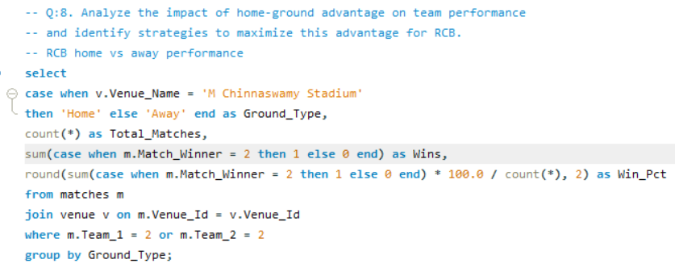
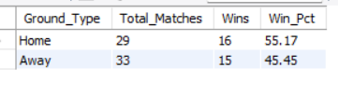
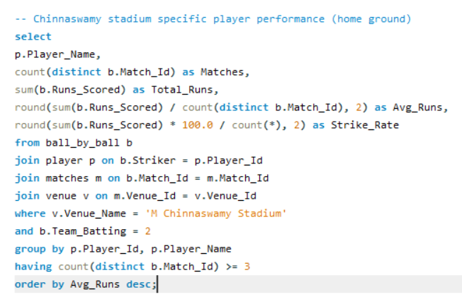
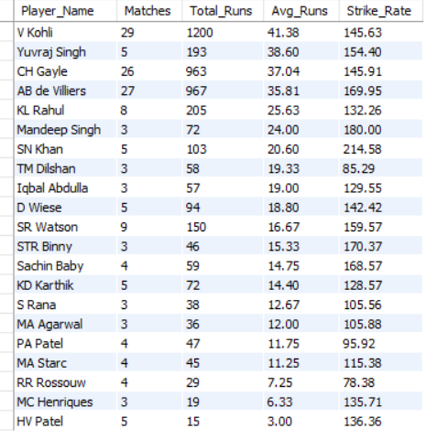

Insights
- 10% win rate difference between home and away: 55.17% at Chinnaswamy vs 45.45% elsewhere. This gap is significant in T20 cricket where margins are razor thin. Home advantage is real and measurable for RCB
- V Kohli at Chinnaswamy (41.38 avg, 145.63 SR, 29 matches): Most matches and highest runs at this venue. Kohli is genuinely a different player at his home ground 1200 runs across 29 games is extraordinary consistency
- AB de Villiers at Chinnaswamy (35.81 avg, 169.95 SR, 27 matches): Second most matches at Chinnaswamy. ABD's 169.95 SR at home shows he plays with extra freedom on familiar ground, making him even more dangerous than his already elite overall stats
- CH Gayle at Chinnaswamy (37.04 avg, 145.91 SR, 26 matches): Third highest home performer. Gayle's flat-pitch hitting at Chinnaswamy is perfectly suited to the venue's batting-friendly conditions
Recommendations
- Play to Chinnaswamy's strengths: flat pitch, short boundaries, true bounce. Build a squad with aggressive openers and power hitters who thrive in these conditions
- Target bowlers who perform at Chinnaswamy: from Q13 analysis, CJ Jordan (3.00 avg wickets in 4 matches) and YS Chahal (31 wickets in 17 matches) are proven home ground bowling specialists
- Use toss wisely at home: S1 analysis showed fielding first at Chinnaswamy wins 51.85% vs batting first 33.33%. Always field first when winning toss at home

- Come up with a visual and analytical analysis of the RCB's past season's performance and potential reasons for them not winning a trophy.

Answer:
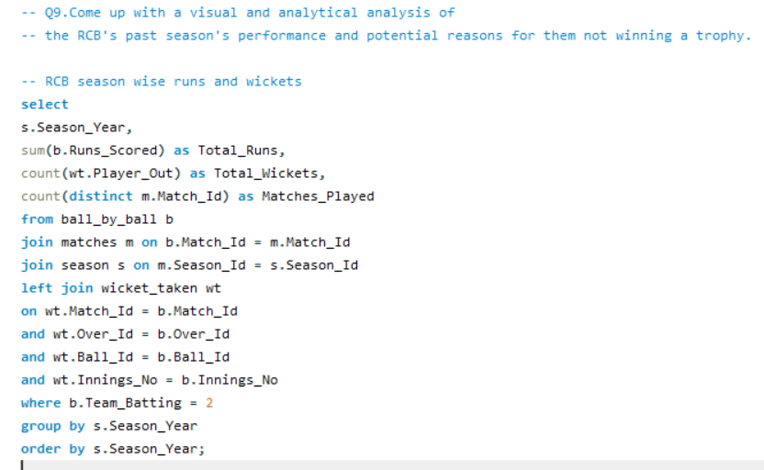


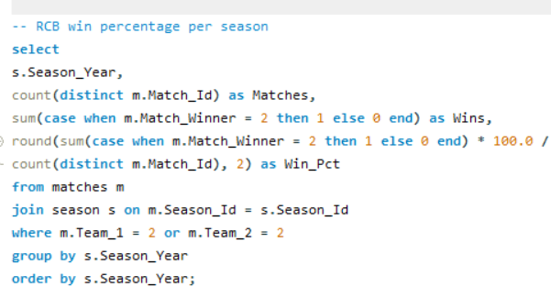
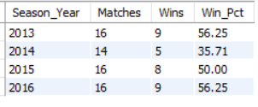

Insights
- 2014 was RCB's worst season: only 1992 runs and 35.71%-win rate. Just 5 wins from 14 matches. This was the season RCB's batting collapsed and bowling couldn't compensate, the perfect storm of poor performance
- 2016 was RCB's best batting season: 2859 runs, 9 wins, 56.25%-win rate. They actually reached the IPL 2016 final but lost to Sunrisers Hyderabad. Their batting was exceptional, but bowling let them down at the crucial moment
- The runs-wickets disconnect is the core problem: in 2016 RCB scored their most runs ever (2859) but took their fewest wickets (71). A team scoring 2859 runs should be winning more than 56% of matches, the bowling is actively costing them wins
- Win percentage has been stuck between 50-57% in 3 out of 4 seasons, good enough to reach playoffs but never dominant enough to win the title. Championship teams win 65%+ of matches consistently
Recommendations:
- Fix the bowling, it's that simple: runs have improved every season, but wickets keep declining. No team has ever won IPL with a weak bowling attack regardless of how strong their batting is
- Reduce dependency on Kohli and ABD: need 4-5 match-winners not 2. When the top 2 fail the rest of the team needs to step up

- How would you approach this problem, if the objective and subjective questions weren't given?
Answer
If the questions weren't provided, I would have still approached this systematically. Here's what I would have done:
- First, I would have understood the business objective clearly, RCB needs a championship winning squad within auction budget. This would drive every decision I make
- I would have explored all 18 tables to understand the data structure, checked for quality issues like NULL values, duplicates and spelling errors before writing any analysis query
- Based on the data available I would have naturally identified key areas to analyze player performance, team trends, venue patterns and toss impact, without needing them to be assigned
- I would have built custom metrics like composite scores rather than relying on basic statistics alone, to get a more complete picture of each player's true value

- In the "Match" table, some entries in the "Opponent_Team" column are incorrectly spelled as "Delhi_Capitals" instead of "Delhi_Daredevils". Write an SQL query to replace all occurrences of "Delhi_Capitals" with "Delhi_Daredevils".
Answer:
Upon examining the Matches table, the column "Opponent_Team" does not exist in our schema. The Matches table uses integer foreign keys (Team_1 and Team_2) referencing the Team table, not text team names. Therefore, this specific data inconsistency does not exist in our database structure.
However, the corrective SQL query for the described scenario is:


